Bahria University,

Karachi Campus



LAB EXPERIMENT NO.

**10**

LIST OF TASKS

|  |  |
| --- | --- |
| TASK NO | OBJECTIVE |
| 1 | Name the fields in IP header. |
| 2 | What is the IP address of your computer? |
| 3 | Within the IP packet header, what is the value in the upper layer protocol field? |
| 4 | How many bytes are in the IP header? How many bytes are in the payload of the IP Computergram? |
| 5 | Explain how you determined the number of payload bytes. |
| 6 | Has this IP Computergram been fragmented? Explain how you determined whether the Computergram has been fragmented. |
| 7 | What is the value in the Identification field and the TTL field? |
| 8 | What information in the IP header indicates that the Computergram been fragmented? What information in the IP header indicates whether this is the first fragment versus a latter fragment? |

Submitted On:

20/12/23

**LAB 10 CAPTURING IP HEADER USING WIRESHARK**

1. **Name the fields in IP header.**

* Differentiated Services Field
* Flags
* Header CheckSum
  + Source
  + Destination

1. **What is the IP address of your computer?**

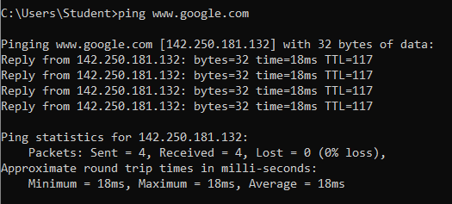

**4 requests send**

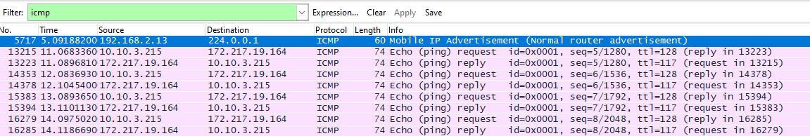

Then we click any of the packets and we will get Source inside Header Checksum



1. **Within the IP packet header, what is the value in the upper layer protocol field?**

**ICMP(1)**

1. **How many bytes are in the IP header? How many bytes are in the payload of the IP Computergram?**

IP Header = 20

Total Length = 60

Then Payload = 40

1. **Explain how you determined the number of payload bytes.**

**Payload Bytes = Total Bytes – Header Length**

1. **Has this IP Computergram been fragmented? Explain how you determined whether the Computergram has been fragmented.**

The "Identification" and "Fragment offset" fields in the IP header indicate that a datagram has been fragmented.

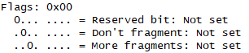

1. **What is the value in the Identification field and the TTL field?**





1. **What information in the IP header indicates that the Computergram been fragmented? What information in the IP header indicates whether this is the first fragment versus a latter fragment?**

The "Identification" and "Fragment offset" fields in the IP header indicate that a datagram has been fragmented.

The Flags bit for more fragments is set, indicating that the datagram has been fragmented. Since the fragment offset is 0, we know that this is the first fragment.